INSTRUMENTATION STUDY CENTRE Registration No: S / 2L / 4187 Period From: 24TH April 2013 To: 23rd April 2014
2014

Address | 50B, Central Road, Jadavpur, Kolkata – 700 032
Telephone number | 9831762415
Email address | nabin.b.manik@gmail.com
Website address | www.instrumentationstudy.org

[Type the document subtitle]
Pallab

50B, Central Road, Jadavpur, Kolkata – 700 032

INDEX
Our Mission…………………………………………………… 3
Origin ……………………………………………………....... 3
Governing body ………………………………… 4
Our course structure ………………………………………… 4
Teacher List …………………………………………………… 5
Activities for the year 2013-14 ………………………… 6- 10
Celebration of foundation day …………………………… 7
Name of the participants ……………………… 10
Certificates …………………………………… 10
Different Application Forms ………………………………… 11
Few letters of general interest ………………………… 12-13
Message from the President …………………………… 14
Annual audit report ………………………………………… 16-17

Our Mission:
Main purpose of our centre is to encourage the young students in the field of electronics nd instrumentation. Demonstration of different electronic models, working principle of some commonly electronic items will encourage the students to grow some interest in this field. This may also help to develop a general awareness in the field of technical science. It will strengthen our technical education. Knowing some techniques the students may also get some scope to use it commercially. They can also set up small scale business in this field. Our society will definitely be enriched by our effort. Different write ups on different aspects of electronics and instrumentation including its impact on our society and culture may be useful. Basically this is a self sponsored, low budget program. Apart from our regular teaching and research we try to do this work. Around 50 students may be trained in our homely environment every year. But we believe that except the training of 50 students, some of our ideas may be useful to develop a general awareness in the field of electronics and instrumentation of our society. In that sense our activity has a broader meaning. We also request all the resourced persons, business persons and organizations to encourage the technical education of our young generation to equip their hands whenever it is possible. Some others may take initiation to set up different technical training centers/institutes. This may be treated as our appeal in general.
Origin:
For last three years when it was initiated there was no such infrastructure. Dr. Manik provided some fund and infrastructure to start its initial work. He had trained few boys/girls. Initially it was started in one small office of 100 sq. ft. at 8B, Jadavpur, Kolkata - 700 032 in a rental basis.. At present still it has no space of its own. At present one portion of the office space of Dr. Manik is used for this purpose which is located at 8B, Jadavpur. One permanent space is needed in future.

Location : 50 B, Central Road, Jadavpur, Kolkata - 700 032
Registration no: S / 2L / 4187 of West Bengal, 2013
Pan No: The Centre has its PAN Number
Branch Office : The Centre has some branch at different places.

Governing body :
President : Dr. Nabin Baran Manik
Vice President : Md. Rabiul Islam
Secretary : Md. Mahinuddin Molla
Jt. Secretary : Smt. Sujata Chakrabarty
Treasurer : Sri Pradip Dalapati

Members:
- Dr. Subhasis Maity
- Dr. Ajanta Haldar
- Piyas Biswas
- Mrinal Ghorai
- Pallab Das
- Animesh Biswas

Visitors:
- Ashok Kumar Nanjundan, Researcher, Dublin 2, IRELAND .
- Prashanth Menezes , Scientist, Germany
- Surjeet Singh , Professor, Pune
- Soumyanetra Chowdhury, doing job in IT Sector
- Dr D R Prasada Raju, Scientist-G/Adviser, DST, India
- Arunabha De, Business Person
- Antara Mitra, Lecturer, Humanities
- Saikat Adhikari, Business Person
- Bimal Jyoti Sengupta, Retd/ G.S.I
- Sudipta Lahiri, Retd/ Geological Survey of India (Rtd)

Our Course structure :
Our main target is to help student to grow interest in electronic and instrumentation.
We will follow the style of our presentation in three steps.

i. Know this technical world :
In this section we will discuss about the history of the technological development. By some slide show we will present a chronological development of technology. We will show from the beginning of the discovery of fire by the ancient people to the space craft invention by the present day scientist.
ii. Get to know what the seniors are doing:
In this section we will try to simplify the working principle of some instruments. We will also tell the story of the major inventions and the inventors.
iii. Do and know by your self:
In this section we will show them how they can also do something by themselves. This section comprises some experimental and theoretical study. You are requested to select few websites/books etc for this purpose.

Theoretical study :
In this section we will discuss basic idea of electronics and instrumentation. Some
literatures for kids electronics my also be included.
You are requested to select few websites/books etc for this purpose.
List of Teachers:
SL. No | Name | Qualification | Email id
1 | Dr. N. B. Manik | M.Sc, Ph.D, | nb_manik@yahoo.co.in
2 | Dr. Ajanta Haldar | M.Sc, Ph.D | ajanta_halder@rediffmail.com
3 | Dr. Subhasis Maity | M.Sc, Ph.D | mailsubhasis@yahoo.com
4 | Dr. Md. Rabiul Islam | M.Sc ,Ph.D | Rabiulislam76@yahoo.co.in
5 | Sutapa saha | M.Sc | Saha.sutapa@ymail.com
6 | Sujata Chakraborty | M.Sc | Sujata.rupa@gmail.com
7 | Pradip Dalapati | M.Sc | physicspradip18@gmail.com
8 | Pallab Das | M.Sc | Pallab.das86@gmail.com
9 | Kailash Mandal | M.Sc | kailashmlp@gmail.com
10 | Chiranjit Maji | M.Sc | chiranjit.juphysics@gmail.com
11 | Falguni Karmakar | M.Sc | karmakarfalguni@gmai.com
12 | Arindam Naskar | M.Sc | arindamnaskar19@gmail.com
13 | Subhasis Manna | M.Sc | mesubjasismanna@gmail.com
14 | Dr. Arun Babu | M.Sc

Activities for the year 2013-14 :
Name of the Participants:

No | Students Received Certificate | Son of
1. | Sibsankar Das, X, 15 | Santosh Das
2. | Subhojit Patra, X, 15
3. | Premangshu Maity, IX, 14 | Manik Chandra Maity
4. | Arindam Maity, IX, 14 | Ajay Kumar Maity
5. | Goutam Patra, IX,14 | Jayanta Patra
6. | Arpan Bhunia,IX, 14 | Shubhranshu Bhunia
7. | Akash Kusum Jana, VIII, 13 | Ashok Jana
8. | Sayan Jana, VIII, 13 | Sandipan Jana
9. | Sayan Kumar Das, VIII, 13 | Sumit Kumar Das
10. | Prasenjit Mandal, VIII, 13 | Basudev Mandal
11. | Soumyabrata Das, VIII, 13 | Swapan Kumar Das
12. | Mriganka Sekhar Jana, VIII, 13 | Kankan eefkumar Jana
13. | Dibyendu Das, VIII, 13 | Bhaktipada Das
14. | Kaustuv Maity, VII, 12 | Kamal Krishna Maity
15. | Sakirul Ali Khan, VII, 12 | Maniur Ali Khan
16. | Arpit Chini, VII, 12 | Sujash Kumar Chini
17. | Souvik Pradhan, VII, 12 | Suresh Chandra Pradhan
18. | Shreyam Maity, VI, 11 | Samir Maity
19. | Arup Bhakta, VI, 11 | Nishikanta Bhakta
20. | Shyamsundar Kar, VI, 11 | Binanda Kar
21. | Subhajit Mandal, V | Basudev Mandal
22. | Jamiul Ali Khan,V | Ayeef Ali Khan
23. | Ujjal Majhi, V | Pranab Kumar Majhi
24. | Saikat Nayek, VIII | Madanmohan Nayek
25. | Parag Keshor Das, VII | Dipak kumar Das

Student presentation in best prize competition:
No | Students Received Certificate | Model Project
1. | Akash Kumar Jana | Wind Mill
2. | Saikat Nayek | Electricity through potato
3. | Sayan Jana | Water Level Indicator
4. | Souvik Pradhan | Working principle of computer mouse
5. | Arpan Bhunia | Working principle of electric iron
6. | Kaustav Maity | Working of electric motors
7. | Arpit Chini | Conduction of electricity through water

Awards: Z. H. Sholapurwala Best Instrumentation Award was given to
Sri Sayan Jana for his work on Liquid Level Indicator

Activities:

1:In this year we have celebrated our foundation day on 23rd April at Kalaberia P.K High School, Charabar, Purba Medinipur, West Bengal .
Celebration of foundation day
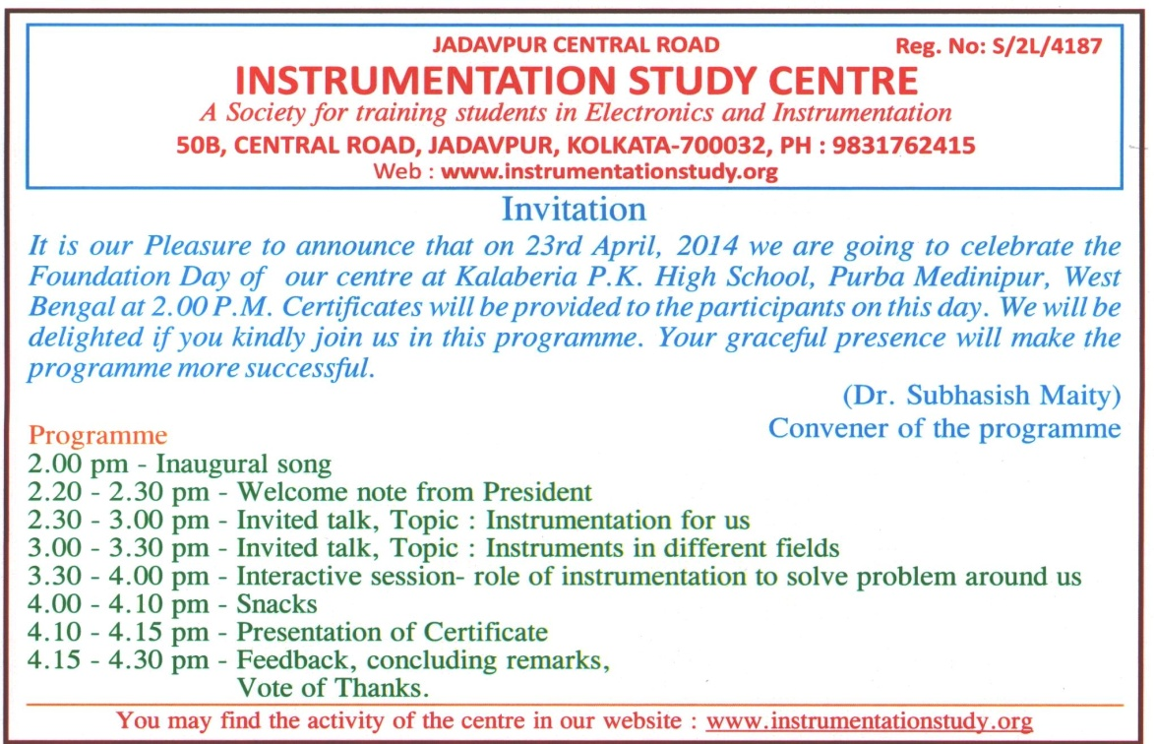

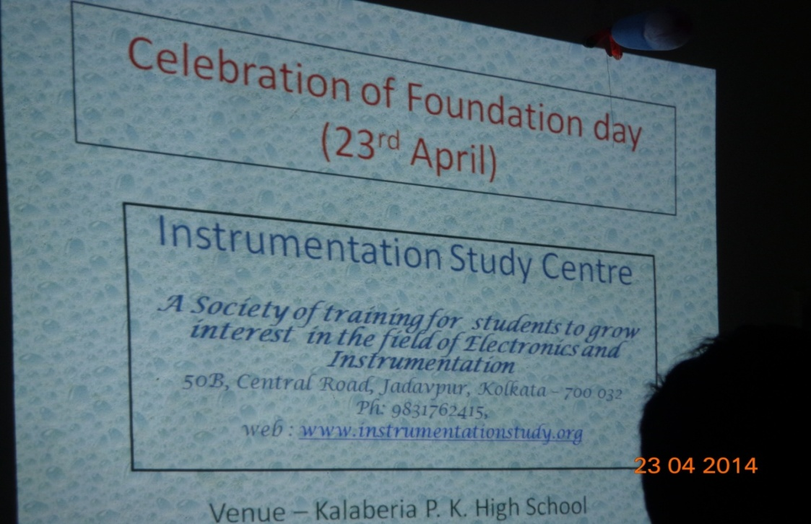

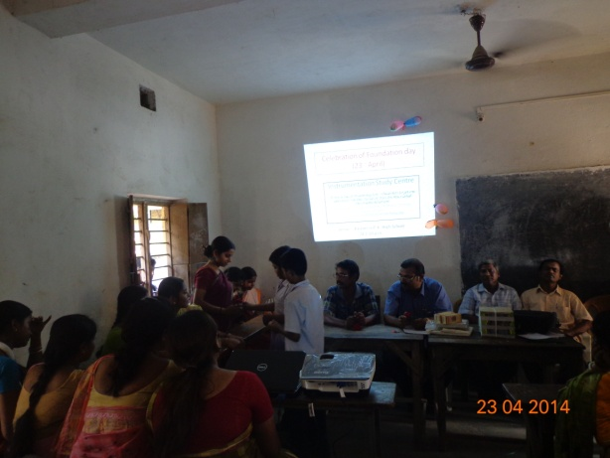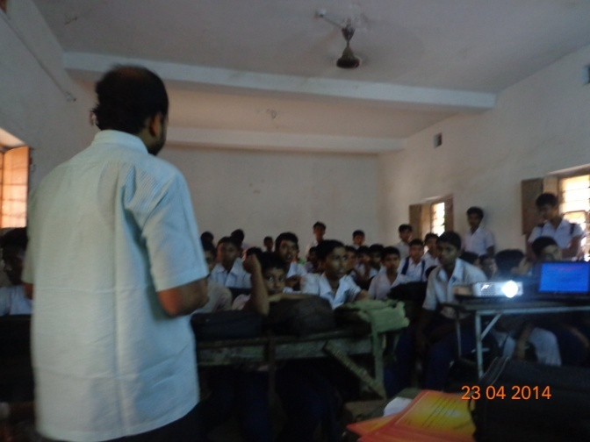

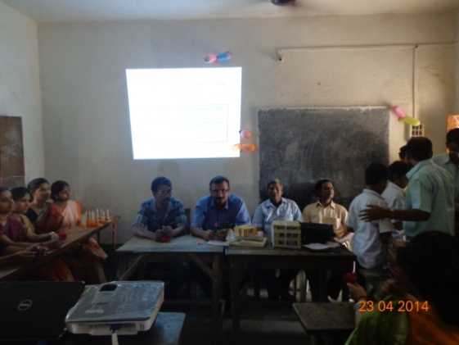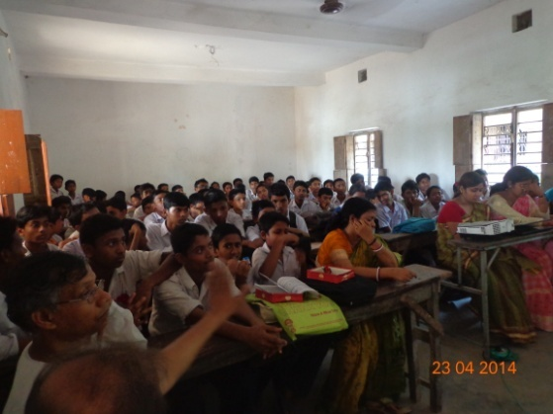

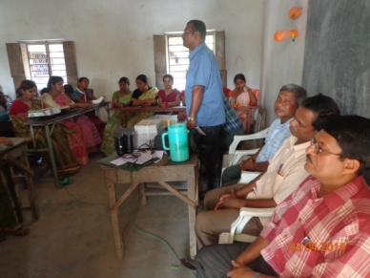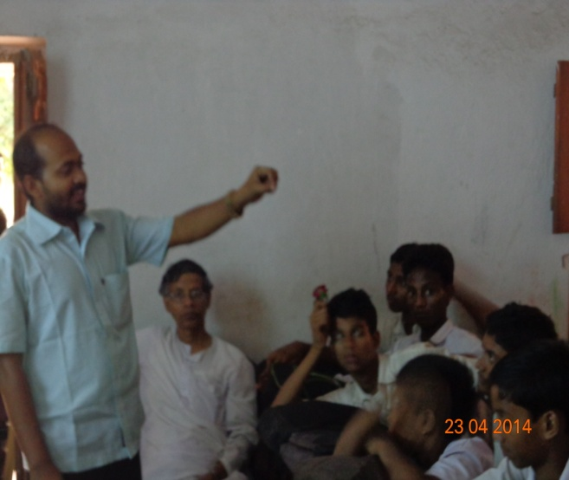
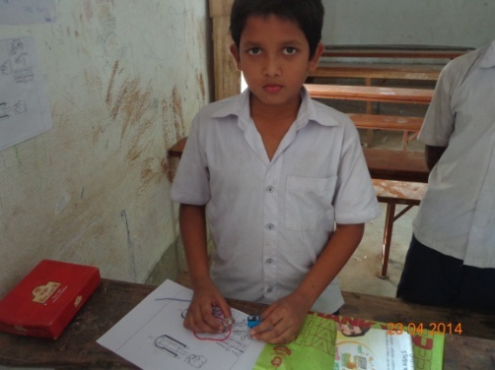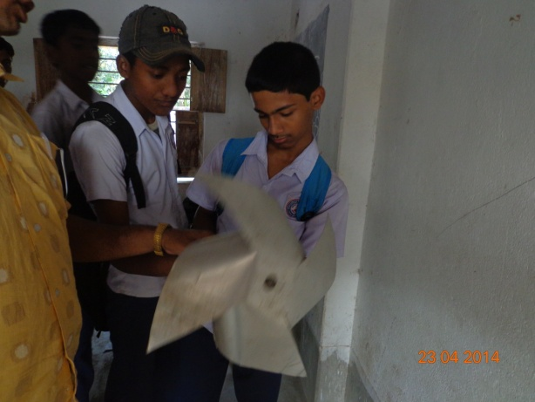
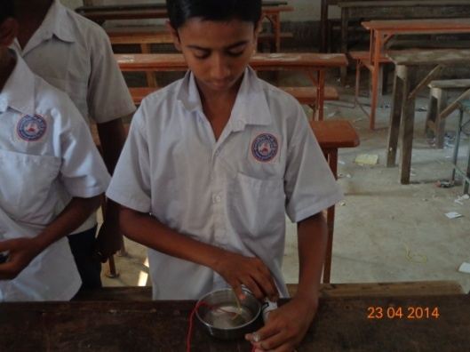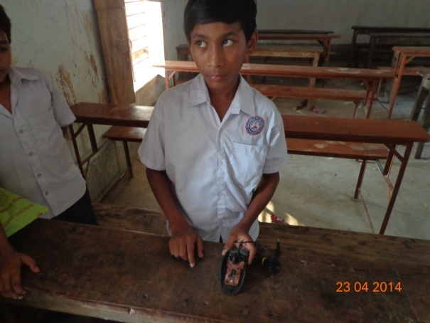
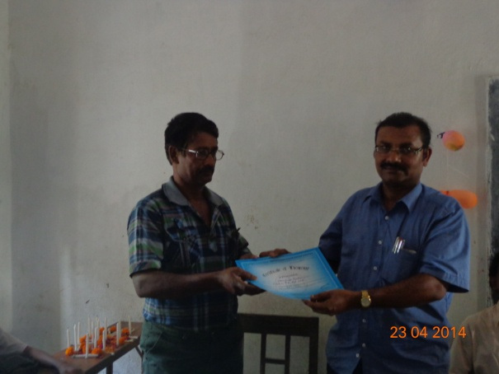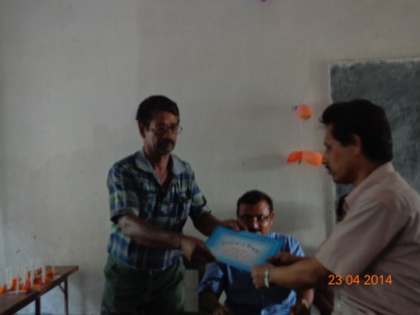
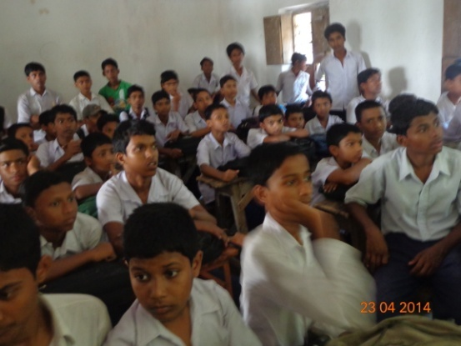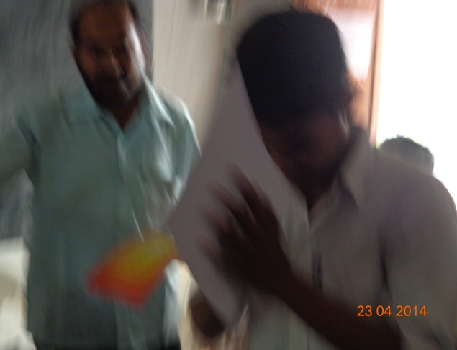

2::Students are awarded with certificates for their courses.
3: Invite lecture was delivered by Si Uttam Kumar Pradhan, Headmaster of Kalaberia P.K. High School and Partha Sarathi Dey ,Assistant Teacher of Kalaberia P.K.High school.
4: Certificates were also provided to the participants in the foundation day.

CERTIFICATES WERE PROVIDED TO THE STUDENTS:

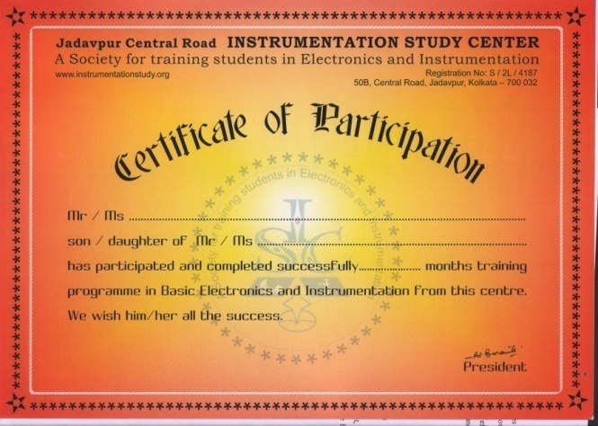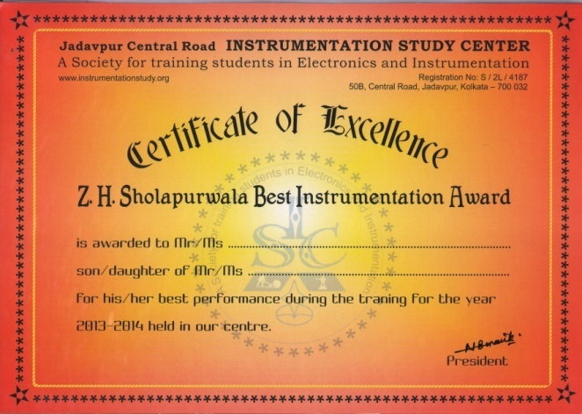
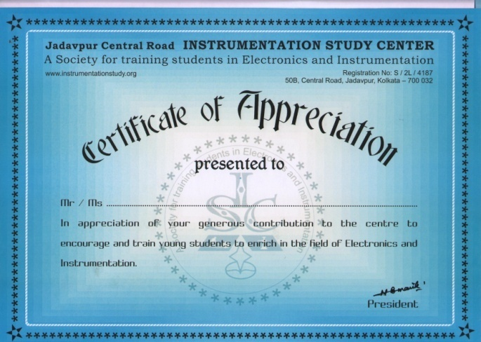

Different application forms:

- Application form for the students admission .

- Application form for the Teachers participation.

- Application form for the membership.

- Application form for the participation in R& D.

- Application form for the demonstration.

- Application form for the taking participation in any other activities.

Different forms for submission of Report

- Format for submission of work report by the students

- Format for submission of work report by the teachers

- Format for submission of final work report for R&D work

- Format for submission of work report by the members

Few letters of general interest

Message from the President

Development of instruments means precise application of our knowledge to take command on our nature and of course to develop a comfortable society with greater economic growth to make life easy, smooth, stable and secured. Without the progress in this field development of the society will definitely be hampered. Practice of instrumentation is also a form to express our intellect. It may also be a good hobby to pass our time joyfully irrespective of our age, gender and education. Research, development, maintenance and other issues related to instruments play an important role in the commercial market and thereby control our daily life. Due to the recent development of science and technology, particularly in the nano regime, a tremendous change is expected in this field. Cost effective, power saving miniaturized design with different new sensors and actuators may be introduced in future instruments. It is our observation that in spite of having sufficient knowledge and skill there are difficulties to exploit it commercially. Different types of new business/applications are not being set up as expected. Desired results will not come unless attention is being paid in this direction. With other sectors, the role of the business persons is important. There is not much scope to address these problems in our regular course work. This is a major reason for which along with our regular training we will give stress on different business/applications aspects related to this field for the cultivation of instrumentation.
Before I conclude I would like to recapitulate again that instrumentation and technology play a major role in our everyday life. Its importance in personal to social life, related economical aspects and other issues like administrative, law-order or even the national and international relation may also be relevant for discussions to grow interest among the students. Business is needed and for that one should know what things are required and where from and how those things may come. Generally the commercial and financial theories which deals various aspects of business, also do not address the varieties of business structures in this field to guide one in setting up new business incorporating its various aspects. It is also challenging, even to a policy maker, to formulate the suitable policy to face this technical world along with its emotional counterpart. It is interesting to note that the GDP is increasing along with the increase of dollar to rupees ratio of our country. Attempt to address the problem accordingly is meaningful. Discussion for adaptation or selection from a high budget to low scale home industry suitable for individual is also useful. They may get ideas to introduce new areas of application even with the existing skill and money available in the market.
Considering all the above aspects we have tried set up a small training centre where some needy students can get some scope to nurture different ideas as well as there will be also a scope to exchange views of experienced persons as a general awareness among the common people in this field. The young boys/girls from different sectors, particularly, those who are not getting scope for formal education and are not aware of the subjects like electronics-instrumentation for which laboratory/instrumental facility is essential. Members of my research group particularly who have already completed their work assured me that they will also help in this regard by giving free lectures/training etc. It will be highly appreciated if you kindly extend your kind hand to organize this centre. In any case I hope I will not be deprived from your well wish for its smooth running. Please go the menu 'About Us' to see our specific activity, mode of operation, budget and requirement of the centre.
All the legal and social aspects have been considered with great care. Different suggestions from your side will definitely be appreciated. I hope you will enjoy our activity, its motives, objectives and style. I like to conclude with the expectation that you will be kind enough to extend your hands if so required. To find some of my other works, one may spend a few minutes to visit my website : www.nbmanik.in

Annual Audit report:
